**EXPERIMENT:14**

**Demonstrate Infrastructure as a Service (IaaS) by establishing the remote connection, launching the created VM image, and run on your desktop.**

STEP:1: AFTER, THE COMPLETION OF THE VIRTUAL MACHINE DEPLOYMENT

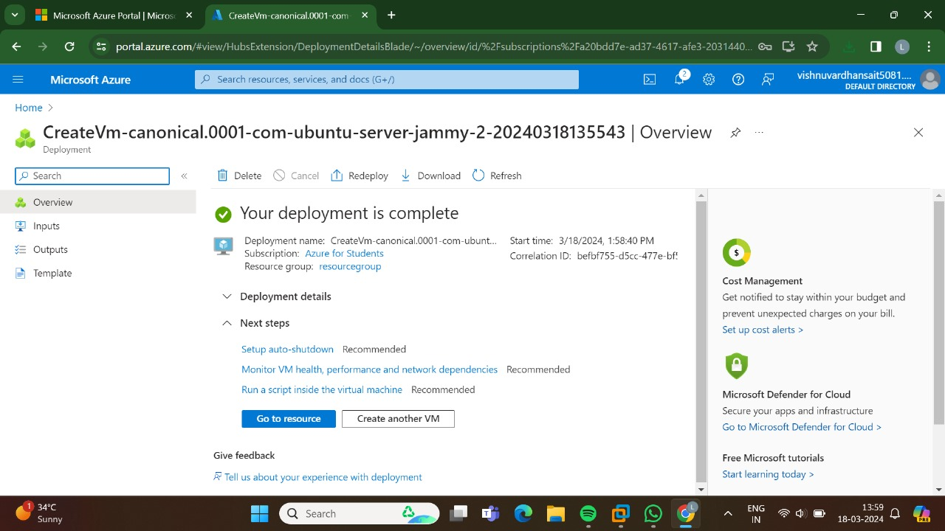

STEP 2: GO TO THE CONNECT.

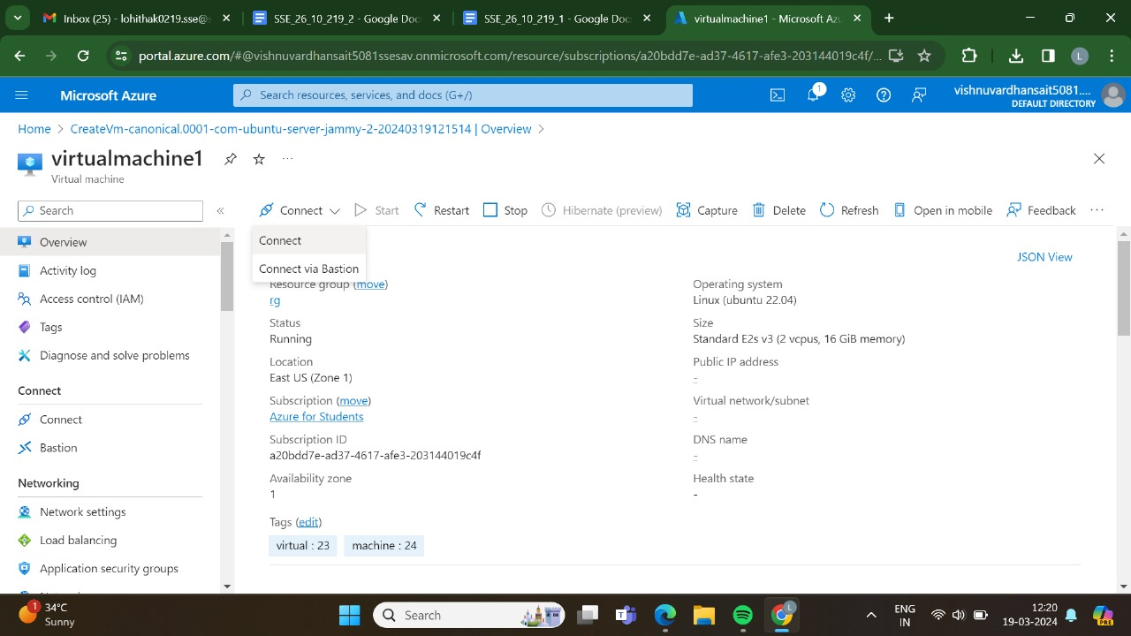

STEP 3: AND,SWITCH ON TO THAT IP ADDRESS.

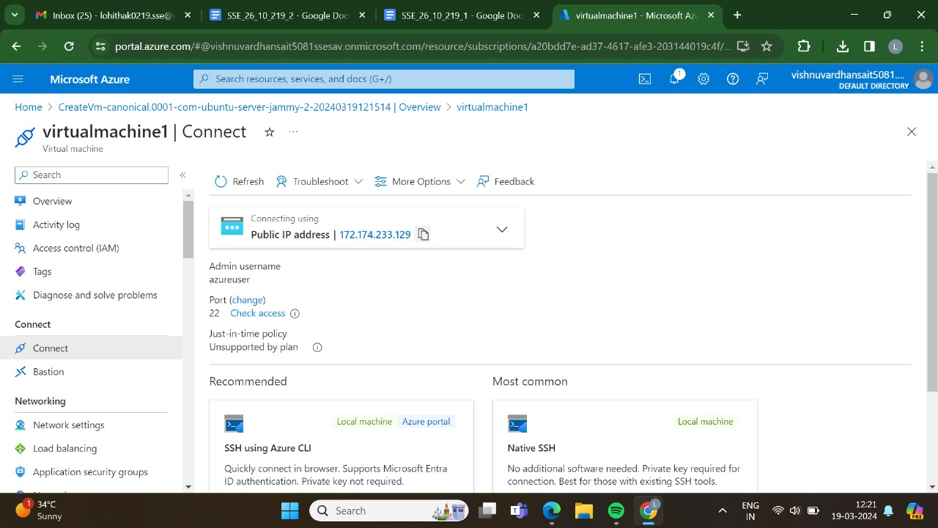

STEP 4: GO, TO THE RECOMMENDED FOR USING AZURE CLI.

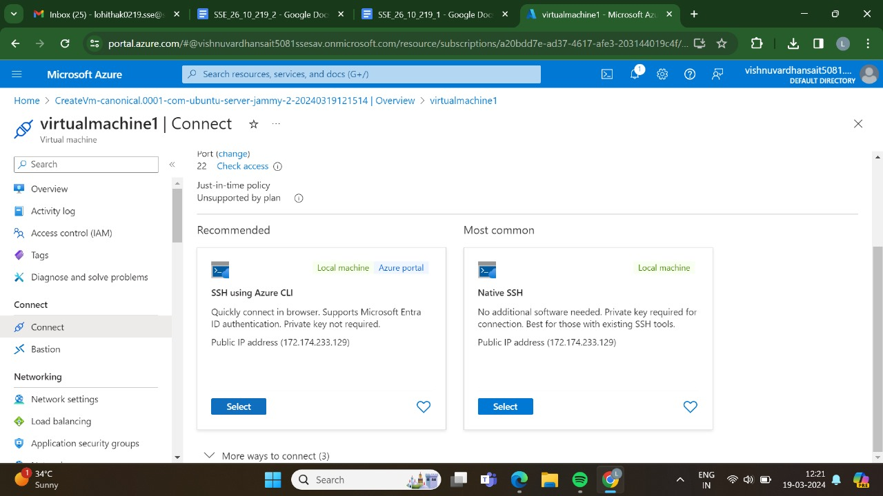

STEP 5: AFTER THET TICK THAT BOX AND GO TO CONGIGURE+CONNECT.

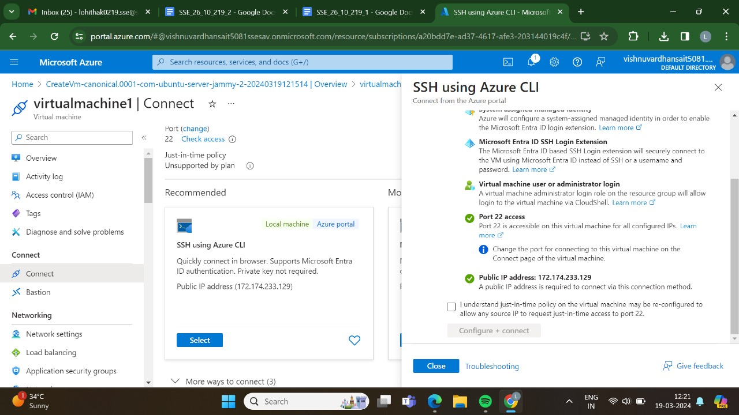

STEP 6:AND ,AT LAST WE THE OUTPUT IS VISIBLE.

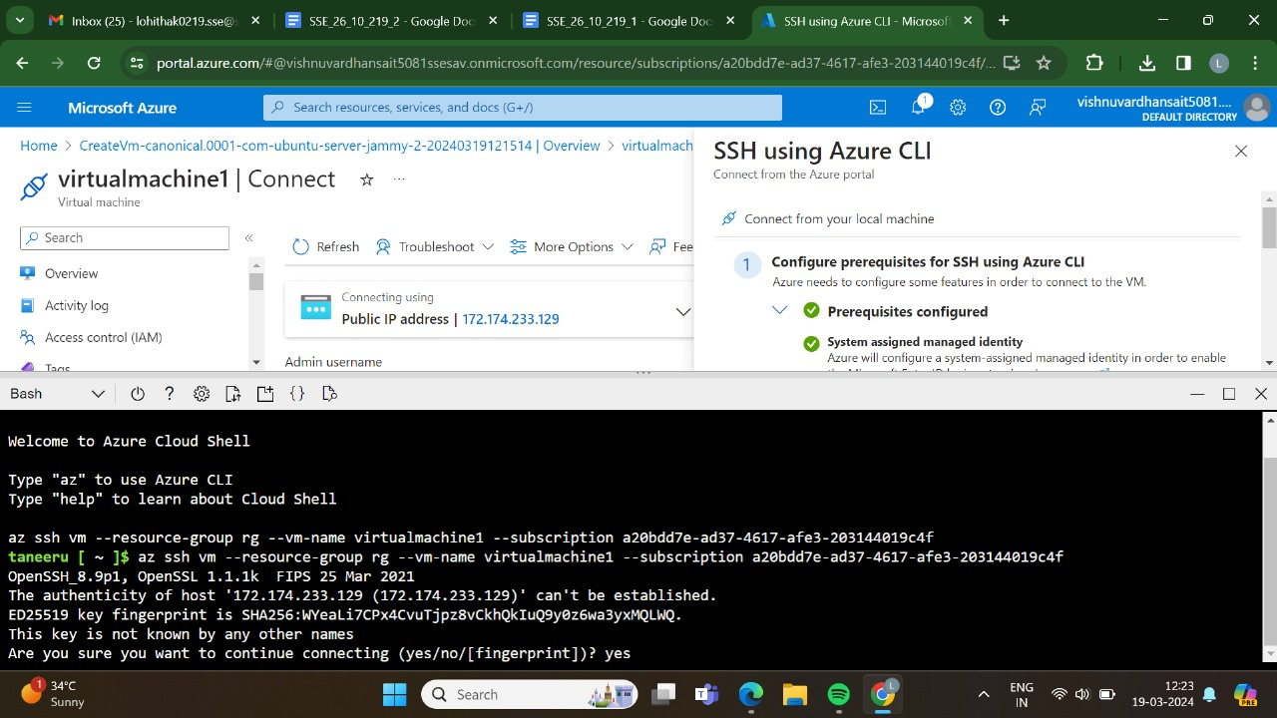

STEP 7: AND,THEN ENTER ALL THE COMMANDS.

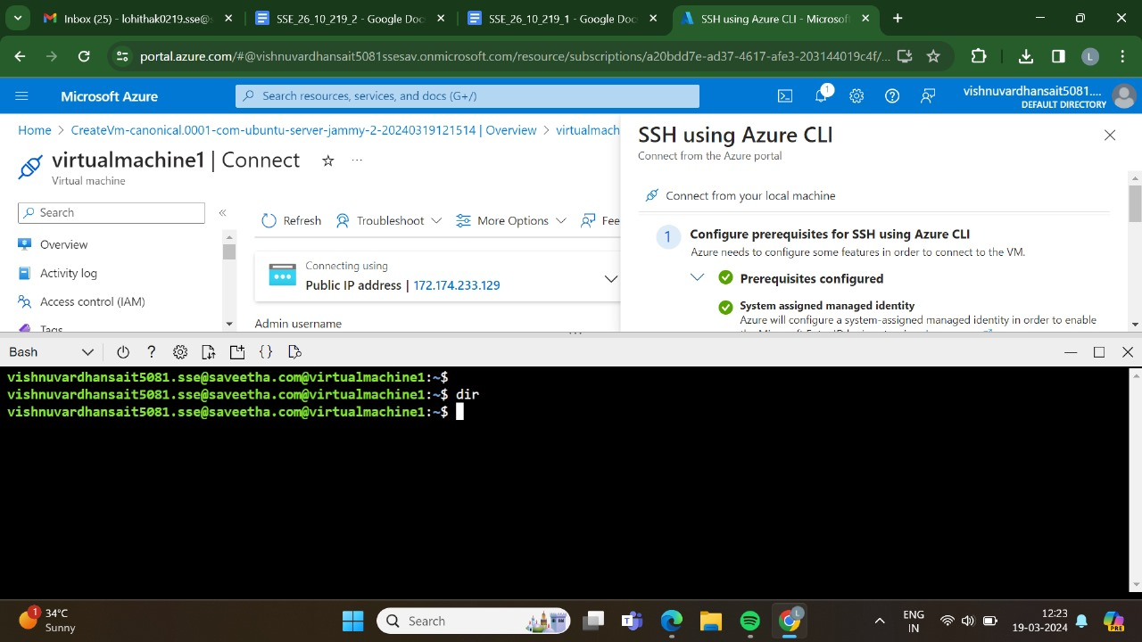

RESULT: THUS,THE PROGRAM FOR THE REMOTE CONNECTION HAS BEEN EXCEUTED SUCCESSFULLY.